##### MEDIUM GG RIPSTOP CROSSBODY BAG

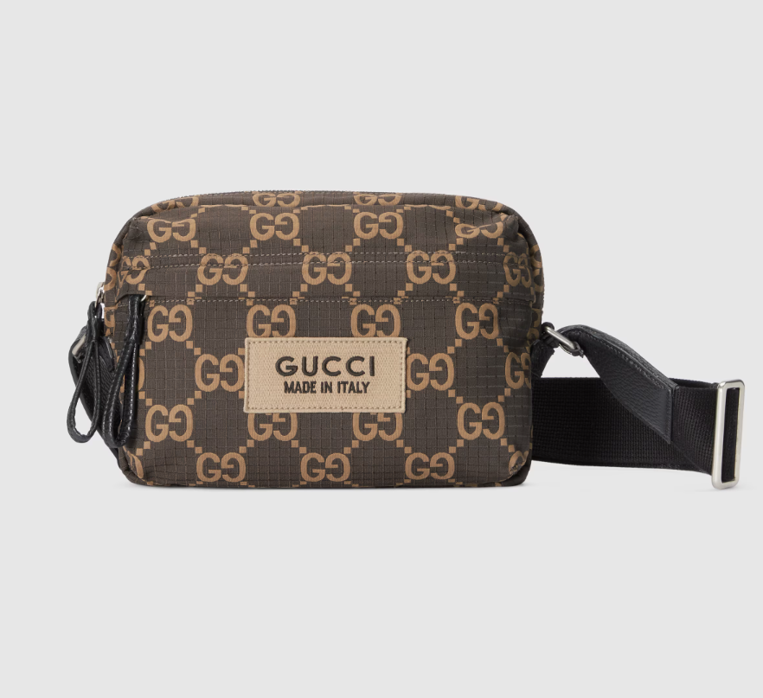

The Medium GG Ripstop Crossbody Bag is another stylish creation from Gucci, featuring the iconic GG monogram print on durable ripstop fabric. Ripstop is a woven fabric that is resistant to tearing and ripping, making it practical for everyday use. This crossbody bag typically features a sleek design with a flap closure and a adjustable strap for comfortable wear across the body. The GG monogram adds a touch of luxury to the bag, making it a statement piece that pairs well with both casual and more dressed-up looks. Gucci often offers this bag in various colors and styles to suit different preferences and occasions.